Requirement Analysis and Structured Data Design Submission on

**School Management System**

Course Teacher: Mr. Aminul Islam  
Assistant Professor,   
Computer Science and Engineering Discipline,   
Khulna University, Khulna  
  
  
  
  
Developed By:

Md. Siam Ahmed (230202)  
Md. Masrafi Murtoja (230207)  
Sobuj Chandra Paul (230231)

Table of Contents

**Interview Questions:** 3

**Observations :** 11

**Business Documents:** 14

**ER Diagram:** 16

**Schema Design:** 17

# **Interview Questions:**

1. Who will be the user of the database?

2. What type of data should be stored?

3.Should the attendance be counted in the result?

4.How should attendance be recorded? (daily / by period)

5.Who should have access to student records? (Only admin or student and teacher also)

6.What authentication methods should be used for user login? (e.g., password-based, OTP, biometric, single sign-on)

7. Besides the admin, should teachers or other staff have access to edit everything?

8.How much information can a general user see when visiting the website?

9.Should class test marks (CT) be counted in the result?

10.How many types of exams does the school conduct? (e.g., Half Yearly, annual Exam)

11. What happens if a student fails a subject? Should they remain in the same class or pass conditionally?

12.Should the system generate printable result cards?

13 Should students be able to request a re-evaluation of their marks?

14. Should the results be publicly available?

15. Who will be responsible for managing and assigning activities?

16.How should student participation be recorded?

17.Should students be able to sign up for activities through the website?

18.Should the system keep records of student achievements in activities?

19. Should achievements be categorized? (e.g., certificates, medals, championship rounds)

20. Who should have access to manage activities? (add, delete, update)

21. Should students receive any advantages based on their performance? (e.g., scholarships)

22. What information should be displayed on the homepage? (e.g., school images, principal’s photo)

23. What details should be shown in the "About Us" section? (e.g., history, principal’s message)

24.Should there be an FAQ section for students?

25. How should student information be displayed? Should their photos be shown?

26. Should records of passed students be maintained? If yes, for how many years?

27. Should students be able to fill out the admission form on the website, or should only instructions be provided?

28. What documents should be submitted during online admission (form fill-up)?

29. Should fees be collected through the website?

30. How should teacher information be displayed on the website?

31. Should there be a system for teachers or students to submit leave applications?

32. Who will approve leave requests?

**Interview Script:**

1.Who will be the user of the database?

Answer: The users of the database will include:

1.Students  
 2.Teachers  
 3.Admins  
 4.General Users

2. What type of data should be stored?

Answer: The database should store the following types of data:

1. **Student Information** – Name, ID, contact details, academic records, attendance, achievements, and admission details.
2. **Teacher Information** – Name, ID, subjects taught, contact details, schedule, and leave records.
3. **Admin Data** – User roles, system settings, and management records.
4. **Exam & Results** – Test scores, final grades, re-evaluation requests, and report cards.
5. **Attendance Records** – Student and teacher attendance logs.
6. **Activities & Achievements** – Participation records, certificates, medals, and scholarships.
7. **User Authentication Data** – Login credentials, role-based access, and security logs.

3. Should the attendance be counted in the result?

Answer: No, attendance should not be counted in the final result.

4. How should attendance be recorded? (daily / by period)

Answer: Attendance should be recorded daily.

5. Who should have access to student records? (Only admin or student and teacher also)

Answer: Only admin and teachers should have access to student records.

6. What authentication methods should be used for user login? (e.g., password-based, OTP, biometric, single sign-on)

Answer: The authentication method for user login should be password-based.

7. Besides the admin, should teachers or other staff have access to edit everything?

Answer: No, only the admin should have access to edit everything.

8. How much information can a general user see when visiting the website?

Answer: A general user can see the following information when visiting the website:

1. **Homepage Content** – School images, principal’s message, and announcements.
2. **About Us Section** – School history, mission, and vision.
3. **Academic Information** – Exam types, curriculum details, and grading system.
4. **Admission Details** – Guidelines, eligibility, and required documents.
5. **Events & Activities** – Upcoming events, extracurricular activities, and achievements.
6. **Student Details** – Basic student information, such as names and achievements (if publicly available).

Sensitive data like student records, exam results, and private details will remain restricted.

9. Should class test marks (CT) be counted in the result?

Answer: Class test marks (CT) should be counted **only for primary school**, but not for high school.

10. How many types of exams does the school conduct? (e.g., Half Yearly, annual Exam)

Answer: The school conducts **two types of exams**:

1. **Half Yearly Exam**
2. **Annual Exam**

11. What happens if a student fails a subject? Should they remain in the same class or pass conditionally?  
Answer: The student remains in the same class and works on improving their academic performance with proper support.

12. Should the system generate printable result cards?

Answer: Yes.

13. Should students be able to request a re-evaluation of their marks?

Answer: Yes.

14. Should the results be publicly available?

Answer: Yes.

15. Who will be responsible for managing and assigning activities?

Answer: The teacher plays a key role in managing and assigning activities to ensure effective learning.

16. How should student participation be recorded?

Answer: A combination of attendance records, assignment tracking, assessments, and teacher observations ensures accurate participation recording.

17. Should students be able to sign up for activities through the website?

Answer: Yes. Allowing students to sign up through the website improves accessibility, efficiency, and record-keeping.

18. Should the system keep records of student achievements in activities?

Answer: Yes.

19. Should achievements be categorized? (e.g., certificates, medals, championship rounds)

Answer: Yes. Achievements should be categorized based on the type of activity to maintain clarity and recognition.

20. Who should have access to manage activities? (add, delete, update)

Answer: Admin and Teacher have access to manage activities.

21. Should students receive any advantages based on their performance? (e.g., scholarships)

Answer: Yes. Students should receive advantages like scholarships, awards, and special opportunities based on their performance to motivate and support their growth.

22. What information should be displayed on the homepage? (e.g., school images, principal’s photo)

Answer: The homepage should primarily display school images, while the principal’s photo should be placed in the principal’s message section.

23. What details should be shown in the "About Us" section? (e.g., history, principal’s message)

Answer: The "About Us" section should include school history, the principal’s message, mission, vision, core values, and an overview of teacher’s and staff.

24. Should there be an FAQ section for students?

Answer: No.

25. How should student information be displayed? Should their photos be shown?

Answer: Student information should include a photo, roll number, and class name while maintaining privacy and security.

26. Should records of passed students be maintained?

If yes, for how many years?

Answer: Yes. Records of passed students should be maintained for 10 years to support administrative needs and future reference.

27. Should students be able to fill out the admission form on the website, or should only instructions be provided?

Answer: Yes. Instructions for filling out the admission form should be provided in a PDF file to guide students.

28. What documents should be submitted during online admission (form fill-up)?

Answer: During online admission, students should submit the father’s NID, mother’s NID, and a testimonial from the previous school as key documents.

29. Should fees be collected through the website?

Answer: No.

30. How should teacher information be displayed on the website?

Answer: Teacher information should display their photo, specialization/subject, and optionally include their name, qualifications, and contact details.

31. Should there be a system for teachers or students to submit leave applications?

Answer: Yes.

32. Who will approve leave requests?

Answer: Admin.

# **Observations :**

1. **System Structure and User Roles**:
   * **Multiple User Roles**: The system is designed for various users, including students, teachers, admins, and general users. Specific permissions are granted to each user based on their role (e.g., students and teachers have access to records, while general users can only view public information).
   * **Access Control**: Sensitive data, such as student records and exam results, is restricted to admins and teachers, ensuring data privacy and security.
2. **Data Management**:
   * **Comprehensive Data Types**: The system stores diverse data types, including student and teacher information, attendance, exam results, activities, achievements, and authentication data, which makes it a centralized platform for school management.
   * **Retention Policy**: Student records are maintained for 10 years, which aligns with common administrative practices, providing easy access for historical reference.
3. **Admission Process**:
   * **Document Submission**: The requirement for submission of documents (e.g., parents' NIDs, previous school testimonials) ensures the authenticity of student applications.
   * **Online Admission**: While the system allows online admissions, it only provides instructions in PDF format, limiting direct form submission on the website, likely to avoid complications in the data collection process.
4. **Assessment and Results**:
   * **Examination Types**: The school conducts two major exams (half-yearly and annually), and class test marks are counted only for primary school, not for high school.
   * **Re-evaluation Requests**: The system allows students to request re-evaluations, ensuring fairness in grading and transparency.
5. **Activity and Achievements**:
   * **Tracking Participation**: The system will track participation, manage activities, and store achievement records (e.g., medals, certificates). Teachers are responsible for managing and assigning activities, while students can sign up for activities online, improving accessibility and ease.
   * **Categorization of Achievements**: Achievements are categorized, which helps in recognizing different types of accomplishments clearly, such as certificates, medals, or championship awards.
6. **General User Access**:
   * **Restricted Access for General Users**: A general user can view basic public information like school history, the principal’s message, event schedules, and FAQs. They do not have access to sensitive or private data.
7. **Teacher and Admin Access**:
   * **Admin Control**: The admin holds significant control over the system, including the ability to manage all data, approve leave requests, and handle overall system settings.
   * **Teacher Control**: Teachers can access student records, manage class-related activities, and submit leave applications, but cannot edit everything like the admin can.
8. **Attendance and Performance**:
   * **Attendance Recording**: Attendance is recorded daily, and it does not affect the final academic result, which aligns with the focus on academic performance.
   * **Performance-Based Advantages**: Students may receive advantages, such as scholarships, based on their performance, motivating them to excel.
9. **Privacy and Security**:
   * **Authentication Method**: A password-based login ensures user security, and access is controlled based on user roles.
   * **Data Privacy**: The system ensures that sensitive information like student performance, leave applications, and personal details are only accessible to authorized users.
10. **Student Engagement and Support**:
    * **Student-Centric Features**: The system focuses on student engagement through activities, achievement tracking, and personalized features like leave applications and re-evaluation requests.

# **Business Documents:**

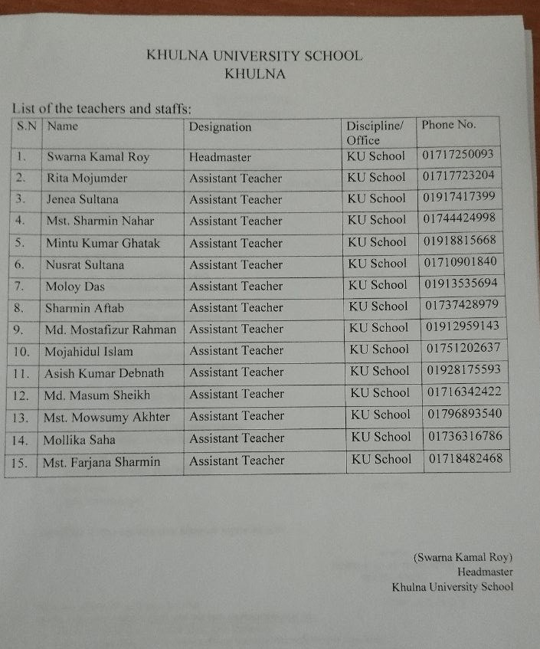

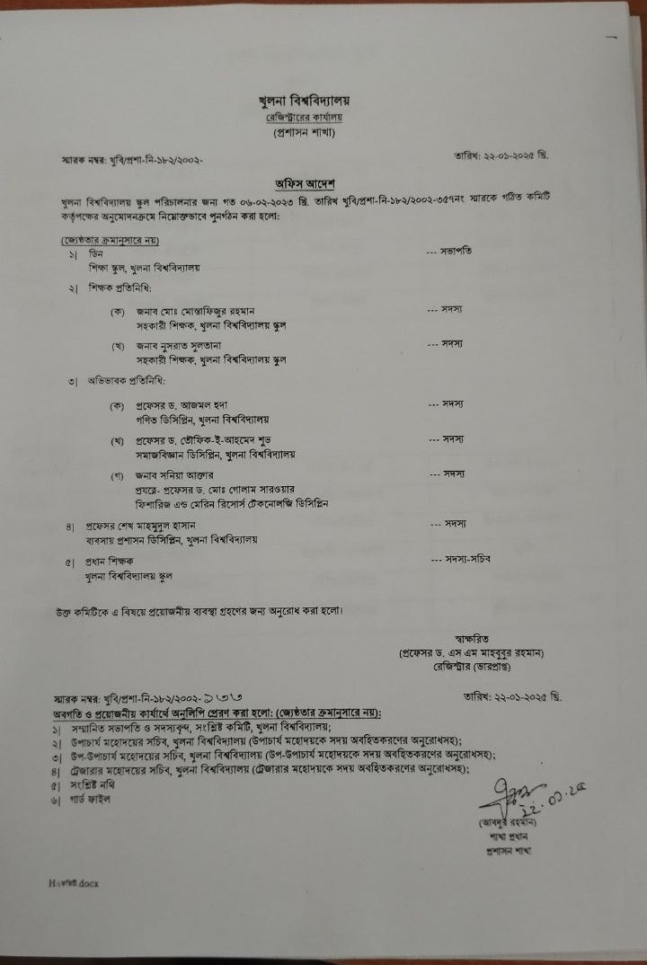

# **ER Diagram:**

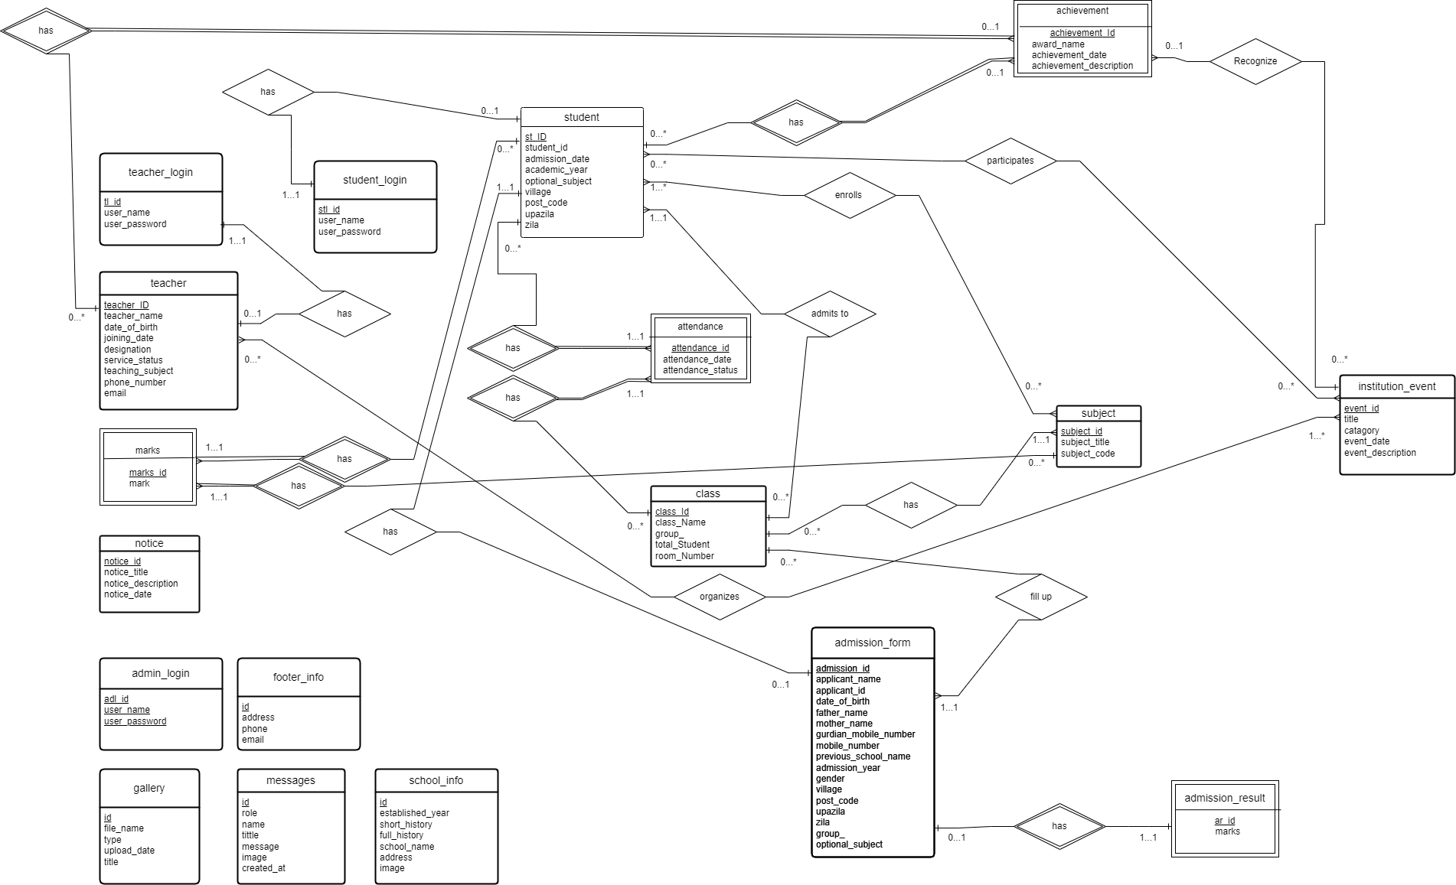­

# **Schema Design:**

admin_login(adl_id, user_name, user_password)

class(class_id, class_name, room_number, group_, total_seat)

admission_form(admission_id, applicant_name, applicant_id, date_of_birth, father_name, mother_name, guardian_mobile_number, mobile_number, previous_school_name, class_id, admission_year, email, gender, village, post_code, upazila, zila, group_, optional_subject)

admission_result(ar_id, admission_id, marks)

student(st_ID, student_id, admission_date, class_id, academic_year, admission_id, optional_subject, village, post_code, upazila, zila)

attendance(attendance_id, attendance_status, st_ID, class_id, attendance_date)

footer_info(id, address, phone, email)

gallery(id, file_name, type, title, upload_date)

institution_event(event_id, title, category, event_date, event_description)

subject(subject_id, subject_title, subject_code, class_id)\

marks(marks_id, mark, st_ID, subject_id)

messages(id, role, name, title, message, image, created_at)

notice(notice_id, notice_title, notice_description, notice_date)

school_info(id, established_year, short_history, full_history, school_name, address, image)

student_event(st_ID, event_id)

student_login(stl_id, user_name, user_password, st_ID)

student_subject(st_ID, subject_id)

teacher(teacher_ID, teacher_name, date_of_birth, joining_date, designation, service_status, teaching_subject, phone_number, email, qualification, district)

teacher_event(teacher_ID, event_id)

teacher_login(tl_id, user_name, user_password, teacher_ID)

achievement(achievement_id, award_name, achievement_date, achievement_description, st_ID, t_ID, event_id)